28.82: The microscopic magnetic moments of an initially unmagnetized ferromagnetic material experience torques from a magnet that aligns the magnetic domains with the external field, so they are attracted to the magnet. For a paramagnetic material, the same attraction occurs because the magnetic moments align themselves parallel to the external field.
For a diamagnetic material, the magnetic moments align anti-parallel to the external field so it is like two magnets repelling each other.

b) The magnet can just pick up the iron cube so the force it exerts is:

But 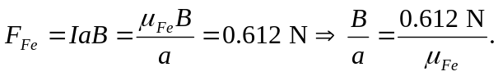
So if the magnet tries to lift the aluminum cube of the same dimensions as the iron block, then the upward force felt by the cube is:

But the weight of the aluminum cube is:

So the ratio of the magnetic force on the aluminum cube to the weight of the cube is
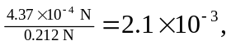and the magnet cannot lift it.

c) If the magnet tries to lift a silver cube of the same dimensions as the iron block, then the DOWNWARD force felt by the cube is:
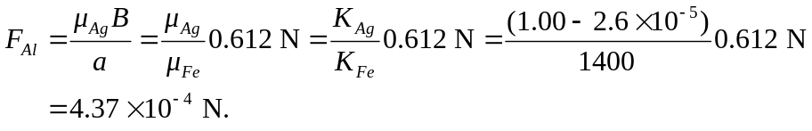
But the weight of the silver cube is:
So the ratio of the magnetic force on the silver cube to the weight of the cube is
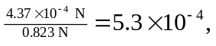and the magnet’s effect would not be noticeable.

